**Level 1: PC Tower Case**

**Outline**

Learn about the internals of a standard PC case by examining physical samples and selecting and labeling images found on-line. Gain deeper knowledge by researching and reporting on specific components.

**Questions**

1. 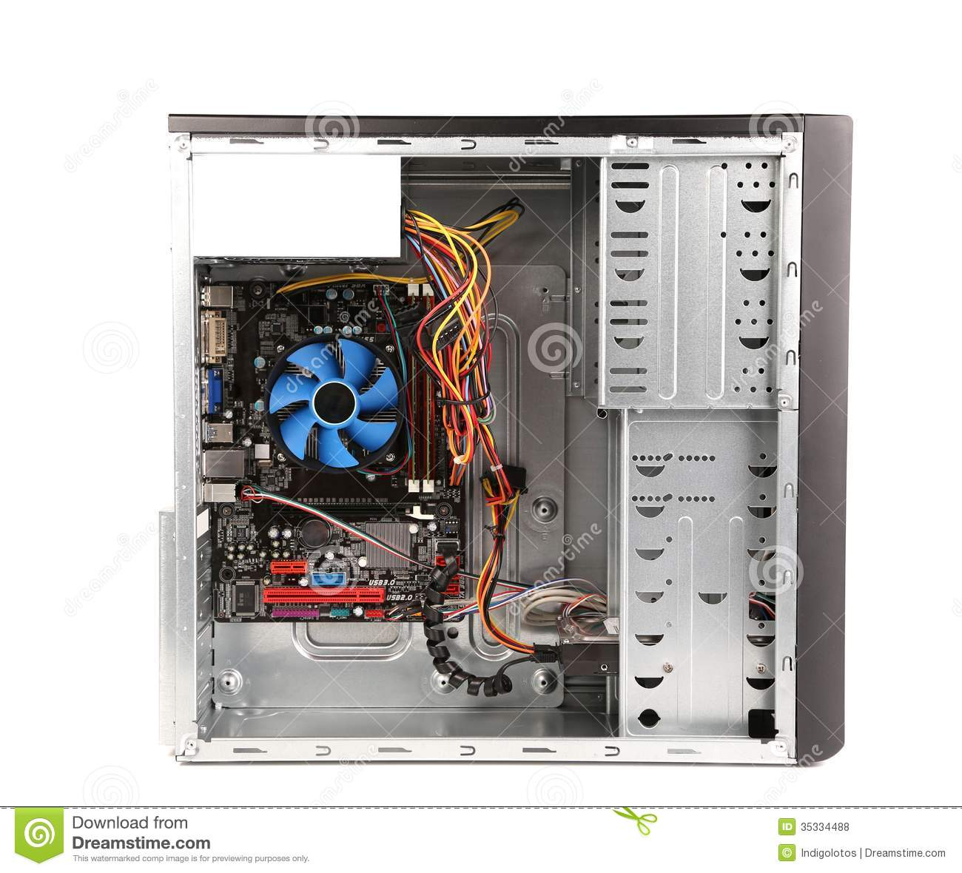Find one (or more) images that clearly show the internals of a PC Tower Case.   
   (i.e. Google images using keywords “PC Case Internals”)

Ethernet Port

Audio Ports

Heat sink fan CPU

Monitor Port

USB Expansion Ports

Optical Disk Drive(e.g.DVD)

Optical Disk drive

motherboard

Hard drive

Power supply

1. Clearly label the following components (using arrows) on your image of the PC case internals:
   1. Motherboard-done
   2. Power Supply-done
   3. Hard Disk Drive-done
   4. Optical Disk Drive (e.g.DVD)-done
   5. USB Expansion Ports-done
   6. Monitor Port-done
   7. Audio Ports-done
   8. Ethernet Port
   9. Cooling Fan-done
2. Research more in-depth about “Motherboards”. Make notes on the following:
   1. What different versions are currently available (speed and capacity)

The different version of the motherboards are ATX Motherboards. The ATX motherboards started in 90's and are still available ,Expansion Slots ,RAM(memory) slots ,CPU Socket, BIOS, CMOS Battery Power Connectors

* 1. How the component has changed since the 1980’s  
       Back in 1980’s, they had two different chips which were called Super I/O and single ICs which was popular back in the 1980’s

1. Research more in-depth about “Hard Disk Drives”. Make notes on the following:
   1. What different versions are currently available (speed and capacity)

The different version that are currently available for hard disk drive is Parallel Advanced Technology Attachment (PATA), Serial ATA (SATA), Small Computer System Interface (SCSI) and  Solid State Drives (SSD)

* 1. How the component has changed since the 1980’s  
     In the 1980s it has changed massively because we keep on getting faster bigger and stronger hard disk drive and get better size and capacity as well. For example, “5.25-inch drives soon gave way to 3.5-inch drives (we at Backblaze still use 3.5-inch drives designed for modern desktop computers in our Storage Pods”.

**Level 2: PC Motherboard**

**Outline**

Learn about the structure of a standard PC motherboard by examining physical samples and selecting and labeling images found on-line. Gain deeper knowledge by researching and reporting on specific components.

**Questions**

1. Find one (or more) images that clearly show the layout of a PC Motherboard.   
   (i.e. Google images using keywords “PC Motherboard”)

Sound processor

Ram Memory

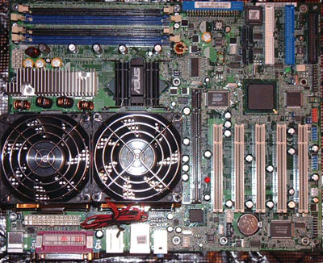

Disk drive interface

GPU

CPU and a fan)

wifi

1. Clearly label the following components (using arrows) on your image of the PC motherboard:
   1. CPU (and fan)-done
   2. RAM Memory-done
   3. Disk Drive Interface (IDE or SATA)
   4. GPU Graphics Processor (either on-board or Graphics Card)-done
   5. Sound Processor (either on-board or Sound Card)-done
   6. Wi-Fi / Ethernet Network Interface (either on-board or Graphics Card)-done

1. Research more in-depth about “CPU Processor Chip”. Make notes on the following:
   1. What different versions are currently available (speed and capacity)

The different version that is currently available are Budget processors, AMD Sempron, Intel Celeron. Mainstream processors, AMD Athlon 64 and Intel Pentium 4. Also “Intel's New 28 Core Monster 5GHz Desktop Processor Is Most Powerful Ever”.

* 1. How the component has changed since the 1980’s  
     In 1823 Baron Jons Jakob Berzelius has invented silicon (Si), which was the first CPU back then and know it has changed a lot because we have new cpu and it works faster as well.

1. Research more in-depth about “RAM Memory”. Make notes on the following:
   1. What different versions are currently available (speed and capacity)

What different versions are currently available (speed and capacity)

    Different versions that are currently available right know for RAM Memory is called DDR4 RAM which is the fastest RAM Memory for your Intel or for your ADM pc.

* 1. How the component has changed since the 1980’s  
     In the 1940s first computer programs were used ultrasonic waves in tubes of mercury. Also, did you know that the latter was the first Random-access memory (RAM)? Since then we are getting faster ram which works better like DDR4 RAM which is the latest RAM right know.

**Level 3: Peripheral Devices**

**Outline**

Learn about how peripheral devices are connected to the back side of a typical PC tower case. Examine physical samples, select and labeling images found on-line and gain deeper knowledge by researching and reporting on specific components.

**Questions**

1. Find one (or more) images that clearly show the layout of the back of a typical PC tower case.   
   (i.e. Google images using keywords “Back Of PC Tower”)
2. Clearly label the following components (using arrows) on your image of the back of a typical PC tower case:
   1. Power cord and power switch-done
   2. Monitor Interface (VGA or DVI or HDMI)-done
   3. Mouse Interface (USB or PS/2)-done
   4. Keyboard Interface (USB or PS/2)-done
   5. USB Ports-done
   6. Audio Inputs / Outputs-done
   7. Ethernet Interface-done

1. Research more in-depth about “Monitor Technology”. Make notes on the following:
   1. What different versions are currently available (e.g. VGA / DVI, Flat Panel Technology))

These are the different version that is currently available for monitor technology which are: Asus ROG Swift PG27UQ, Acer Predator X34, Dell UltraSharp UP3218K, Asus MG248Q and etc…

* 1. How the component has changed since the 1980’s (e.g. Display Resolution, Technology)  
     The Display resolution technology has evolved since its early days using a mechanical system

1. Research more in-depth about “External Portable Storage”. Make notes on the following:
   1. Floppy Disks

Floppy disk is a flexible removable disk used for store data

* 1. CD-ROM / DVD / Recordable CD/DVD

A CD-ROM/DVD is an optical **disc** which contains audio or software data whose memory is read-only

* 1. USB Memory Drives

USB Memory Drives is a data storage where all of your files or drives can be saved in a USB

* 1. Compact Flash Memory

It is a  mass storage device used mainly in portable electronic devices

Cloud Based Storage  
Cloud-Based Storage is an in which data is stored on remote servers accessed from the internet, or "cloud."

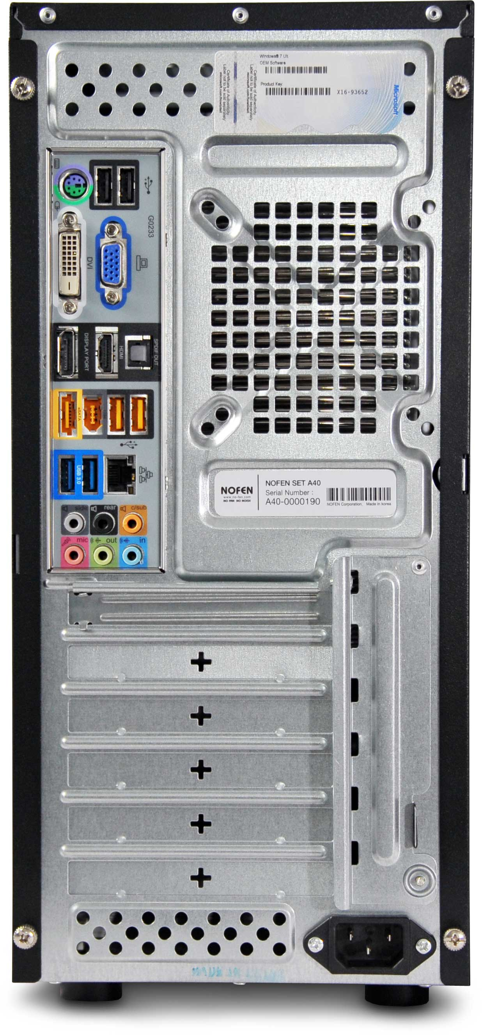

Ethernet Interface

Monitor

Audio input/output

USB

keyboard

Mouse interface

Power Switch